# What are the social outcomes of climate policies? A systematic map of the ex-post literature.

William F. Lamb, Miklós Antal, Katharina Bohnenberger, Lina Brand, Finn Müller-Hansen, Michael Jakob, Jan C. Minx, Kilian Raiser, Benjamin Sovacool, Laurence Williams

## Introduction

## Motivation

## Previous work

## Research question

## Aims

## Materials and methods

## Scope of study

## Search method

## Screening

## Coding

## Results

## Literature, methods and epistemic communities

A short section with a descriptive overview of the ex-post literature.

* Figure with 3 panels: distribution of literature by journals, year, methods

## Policies assessed, their climate outcomes and geographical coverage

A more in-depth section…

* Figure, 3 panels: breakdown of policies covered, their scope (national, subnational), and time of implementation (historical, ongoing)
* Figure: the climate outcomes of assessed policies. No ideas yet. Would like to demonstrate the scope and scale of different measures.
* Figure: world map with coverage of countries/regions/localities assessed, highlight on evidence clusters

## Social outcomes

The main results section, analysing the climate and social outcomes of different policies.

A figure for each policy category (level of aggregation to be determined)…

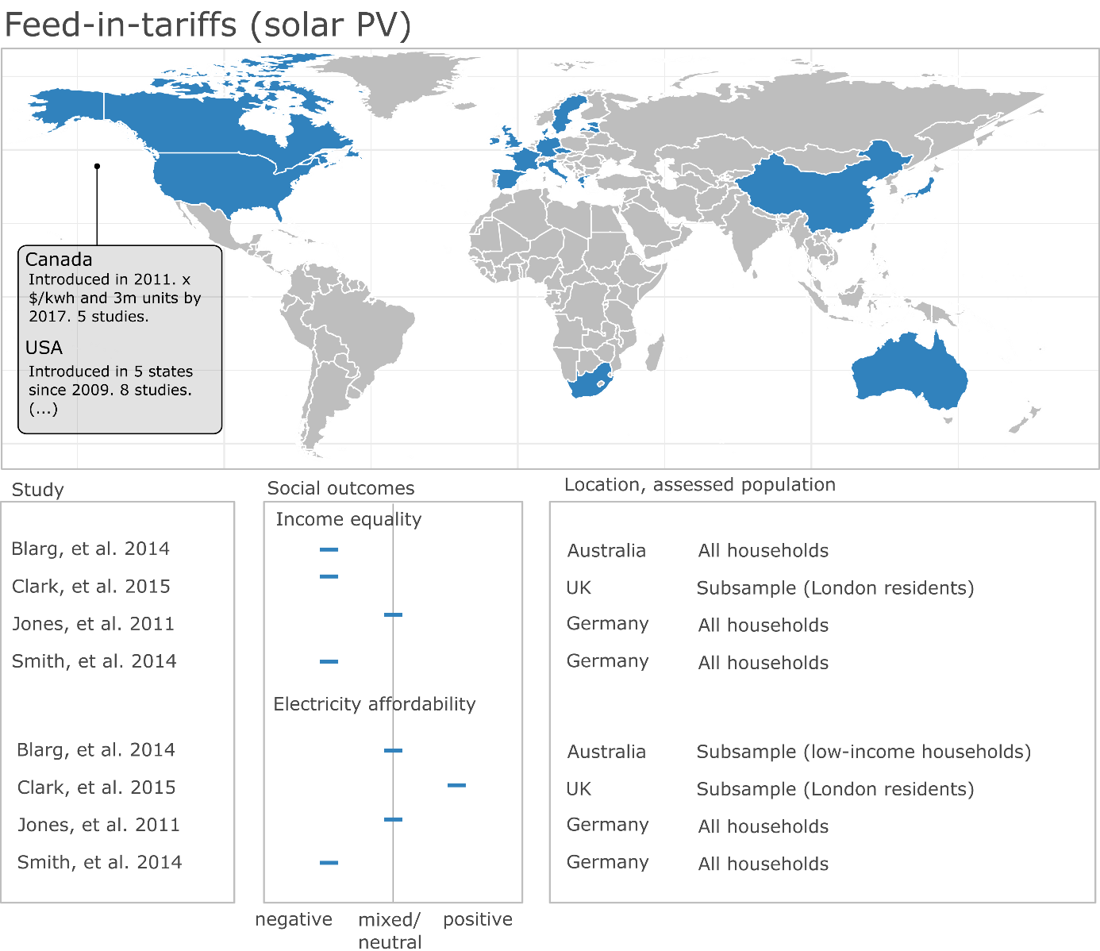

## Discussion

## Conclusion